Scituate's CORSE teaches 95 kids water sports

By Kristi Funderburk, July 27, 2016

Nathan McCusker braced himself on the board as Brian Lannon starts paddling.

Windsurfing could be a little scary to a newcomer, but these Scituate boys aren’t worried. If they mess up, Nathan, 10, explains, “You just fall in. It’s pretty fun.”

The boys were part of a group of 95 local youth to take advantage of The CORSE (Community of Resources for Special Education) Foundation’s seventh annual Maritime Adventures water sports camp.

AccesSport America is teaching skills in adaptive windsurfing, Hawaiian outrigger canoeing, and stand-up paddling, and the town recreation’s sailing staff partnered with CORSE to offer sailing lessons.

This year so many people wanted to participate that CORSE added a second week, foundation president Tracy Johnston said.

The program includes specialized equipment and careful instruction so it’s open to children of all abilities, even if they are non-ambulatory, non-verbal and do not know how to swim, she said. This year’s group is split evenly between children with and without special needs, she said.

“There are some kids that have never been on the water or are afraid of the water, and by the end of the week, many of them are completely independent on the apparatus,” Johnston said.

The main instructor, Ross Lilley, executive director of AccesSport America, is really patient and helpful with the camp participants, she said. Johnston also has about 25 high school-aged volunteers.

Lilley said he enjoys working with the kids.

“The best part is the relationships for us,” he said. “It’s all about engagement and when we see people year after year and day after day, we get to build these relationships.”

Emily Sommers, a Scituate teen who has volunteered at the camp for two years, also enjoys getting to know the kids and getting them on the water.

"I like watching the kids get on the water and do things they don't normally do," she said.

Lilley said he’s impressed with how much of skills the students retain each year.

Johnston said about 30 percent of the participants signed up for two weeks of the camp, while the rest did one week. That new option allowed for repeated exposure to give the kids a better chance to build on and remember their skills, she said.

In a lot of cases, Johnston said, this camp is the participants’ only time to try these sports on the water all year.

“It’s something so unique for CORSE, but it’s not unique because we’re in Scituate,” she said of the program. “People are paddle-boarding all the time on the river, but some kids, if we didn’t bring this group that has the experience and adaptive equipment, they wouldn’t be able to do what everyone was doing.”

Standing on the deck of the Maritime Center as she watched the kids practicing their new skills on the water, Johnston and Judy Geagan recalled when Geagan’s grandson, Hunter, first started with the program five years ago.

Hunter, who has autism, was initially nervous floating out over the water, Geagan said, but any signs of fear were gone this week. Hunter was paddling out and around the docked boats and along the shore, taking advantage of every second on the paddleboard.

“It was awesome,” Hunter, a 16-year-old from Whitman, said when he finally came to shore.

Brian, 12, and Nathan had similar reactions after splashing to solid ground.

“It was fun,” Brian said. “It goes fast, but you don’t have to worry because you can go into the water and sometimes that’s fun.”

He said they had a few days to learn how to windsurf, but felt it was easy to pick up. From there, it was smooth sailing.

“My favorite part is being with my friend on a board,” Nathan said.

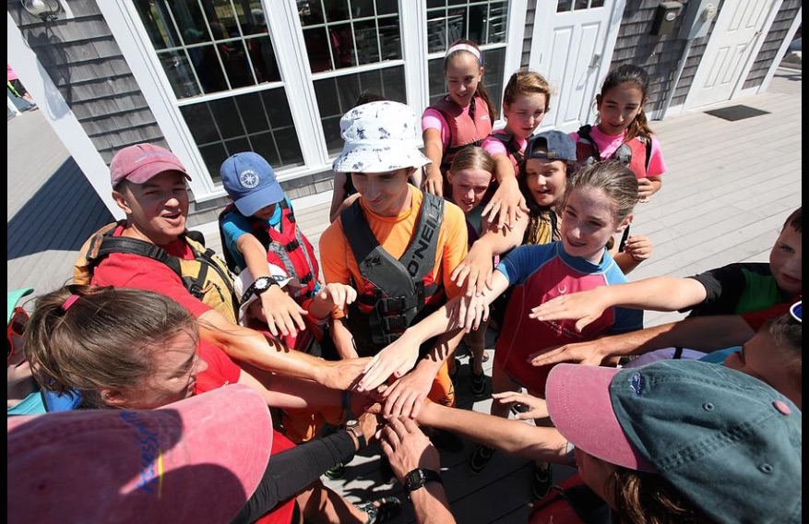

Students and counslors huddle in for a cheer after a successful day on the water on Thursday, July 21. Wicked Local Staff Photo/Robin Chan
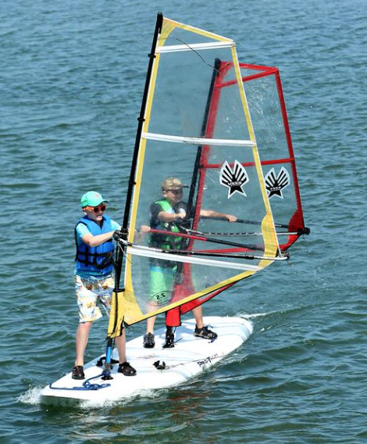
Brian Lannon, 12, of Scituate, and Nathan McCusker, 10, of Scituate, enjoy windsurfing in Scituate Harbor during CORSE's and AcesSports America's Maritime Adventures on Thursday, July 21. Wicked Local Staff Photo/Robin Chan
During Maritime Adventures through AccesSport America (Ages 6-22), athletes got a chance to build skills in adaptive windsurfing, Hawaiian outrigger canoeing, and stand-up paddling.
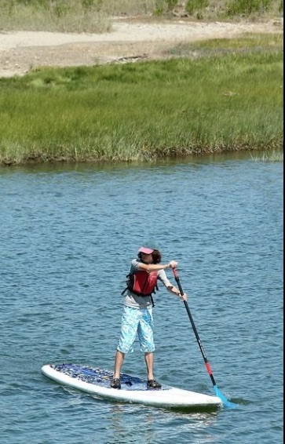
Derek Allen, 13, of Scituate, goes around Scituate Harbor on a paddleboard during Maritime Adventures at CORSE on Thursday, July 21. Wicked Local Staff Photo/Robin Chan
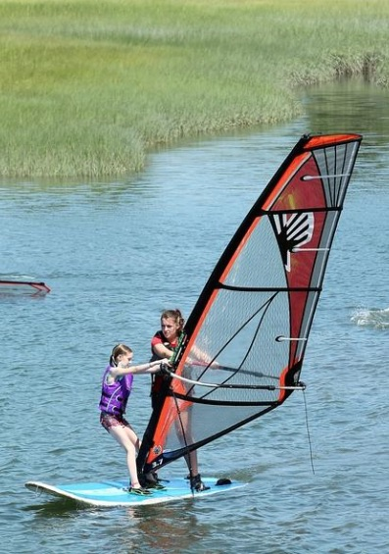
Counselor Kathleen Burke, 22, helps Kelsea Lee, 10, learn how to windsurf at Maritime Adventures at CORSE with the help of AccesSport America on Thursday, July 21. Wicked Local Staff Photo/Robin Chan
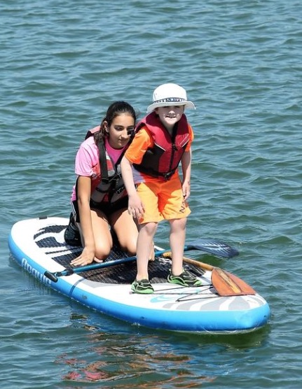
Zachary Geagan, 7, of Whitman, smiles while standing up on the paddleboard after winning a trip to Maria's while Hannah Zaveri keeps an eye on him during their trip on the paddleboards during Maritime Adventures with the help of AccesSport America and CORSE on Thursday, July 21. Wicked Local Staff Photo/Robin Chan

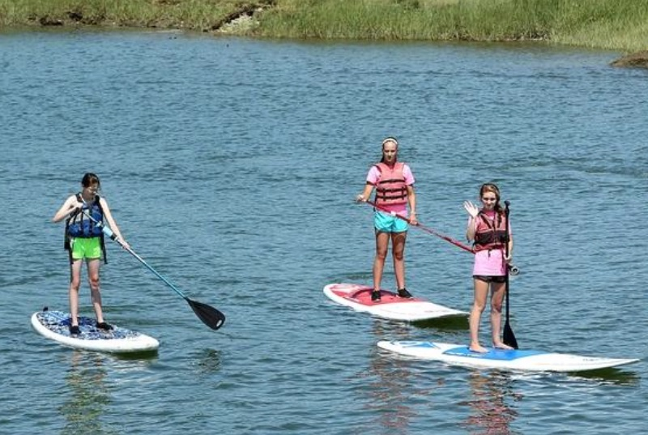
Catherine Stewart, 12, Paige Lydon, 13, and Julia Gates, 15, all of Scituate, head back to shore on their paddleboards during their outing on Thursday, July 21. Wicked Local Staff Photo/Robin Chan

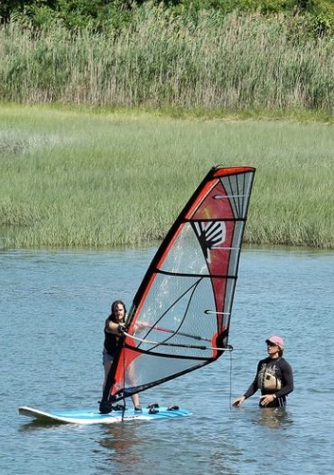
Ross Lilley, executive director of AccesSport America, helps Trea McLaughlin, 12, of Scituate, learn how to windsurf during Maritime Adventure at CORSE on Thursday, July 21. Wicked Local Staff Photo/ Robin Chan

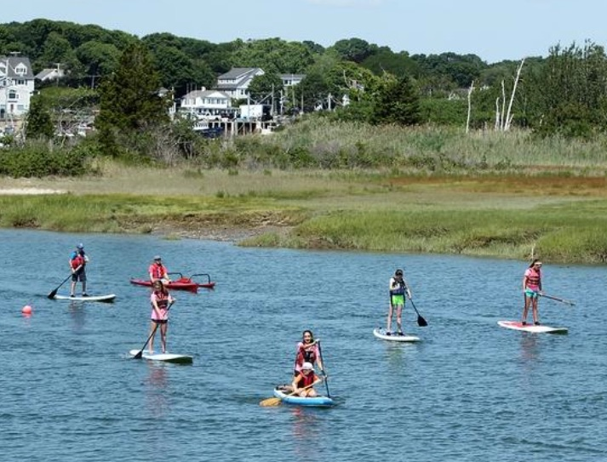
Students from CORSE paddle back to shore after their class was over on Thursday, July 21. Wicked Local Staff Photo/Robin Chan

