Pajama-clad train riders take a quick trip to the North Pole

By Julia Aparicio
The Patriot Ledger
Posted Dec. 9, 2014 @ 11:14 pm
Updated Dec 10, 2014 at 2:29 AM

SCITUATE – There were hundreds of kids in pajamas, Santa Claus, elves and a bit of magic in the air as the Polar Express train left the Greenbush commuter rail station in Scituate.
The train made four runs from the Greenbush station on Sunday. They were among the many Polar Express rides being offered in communities south of Boston during this holiday season to raise money for worthy causes.

The rides recreate the story author Chris Van Allsburg tells in the book “The Polar Express.” A boy in pajamas is taken to the North Pole on a train. He gets to meet Santa Claus, who gives him a bell from his sleigh that only children can hear.
Polar Express rides on the South Shore started nearly a decade ago, and they have grown in popularity.

Children who went on the Scituate rides were entertained by Santa’s elves reading the “The Polar Express” story aloud. The children also sang Christmas carols, had milk and cookies, and enjoyed visits from Frosty the Snowman, Rudolph, Santa and Mrs. Claus.

“The best part of this ride is talking to the kids and making them happy,” said Makenna Carroll, a Scituate High School student who volunteered as one of the elves. “Seeing all of them smiling is incredibly sweet.”
Each child also received a “magical” silver bell as shown in the story.

“It’s great for the kids because they get to hear their favorite Christmas story and really experience it on the train as well,” said Robyn Maguire, who brought her two children on the ride for the first time.

All four of the Scituate rides were sold out – a total of 2,500 tickets.

“My favorite part was hugging the polar bear and getting to jump around on the train,” passenger Rufus Steel, 3, said.
The proceeds will go to two local nonprofits that benefit students: CORSE (Community of Resources for Special Education) and SCORE (Scituate High Opportunities and Resources for Education).

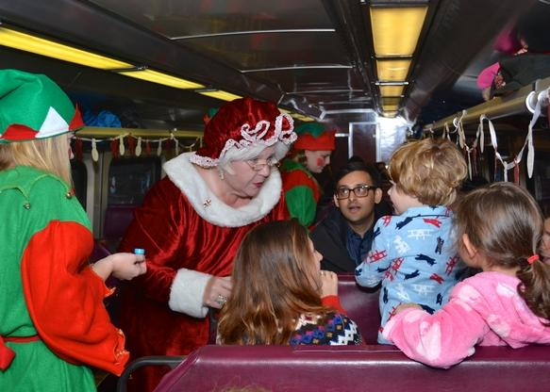

Children met Mrs. Claus aboard the 7th Annual Scituate North Pole Express on Sunday Dec. 7, 2014.

From left, volunteers from Scituate High School Makenna Carroll, Nick Basler, and Gaelyn Murphy aboard the 7th Annual Scituate North Pole Express on Sunday, Dec. 7, 2014.

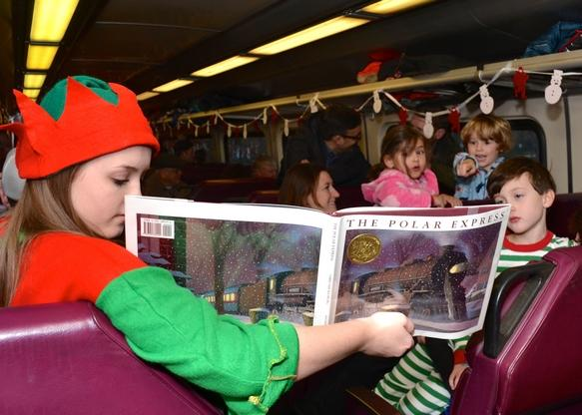

Children reacting to a special reading of "The Polar Express" aboard the 7th Annual Scituate North Pole Express on Sunday, Dec. 7, 2014.

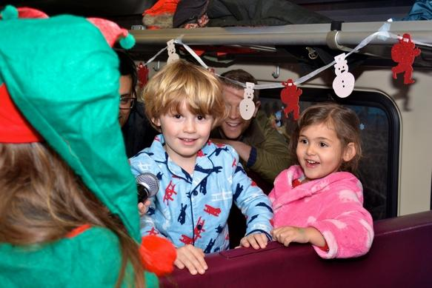
Rufus Steel, 3, and Daisy Mohammed, 3, eagerly awaiting Santa aboard the 7th Annual Scituate North Pole Express on Sunday, Dec. 7, 2014.

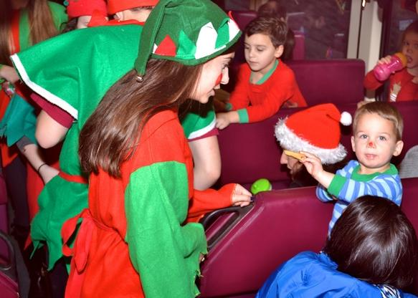

Christmas elves greeting passengers aboard the 7th Annual Scituate North Pole Express on Sunday, Dec. 7, 2014

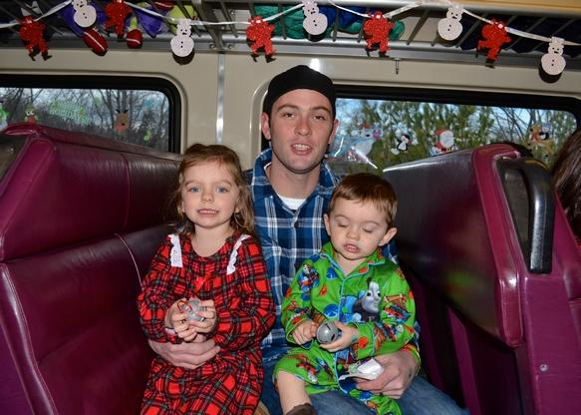

Camryn Kelleher, 4, and her brother Daniel, 2, with their father D.J. Kelleher aboard the 7th Annual Scituate North Pole Express on Sunday Dec. 7, 2014

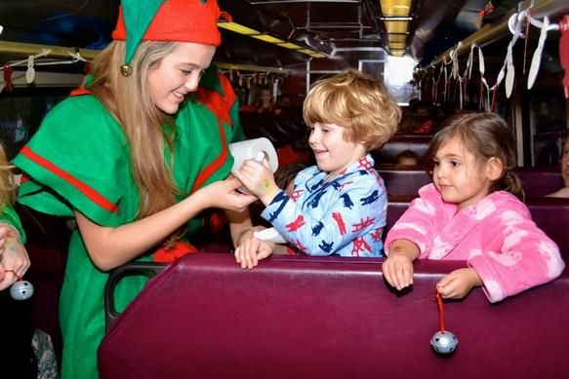

Rufus Steel, 3, and Daisy Mohammed, 3, receiving temporary Christmas tattoos from an elf aboard the 7th Annual Scituate North Pole Express on Sunday Dec. 7, 2014

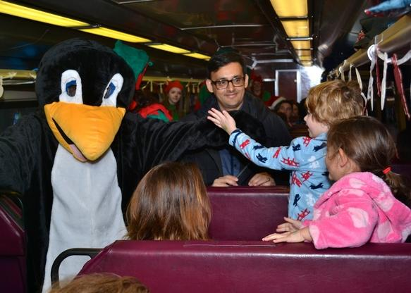

Rufus Steel, 3, receiving a high five from the Christmas penguin aboard the 7th Annual Scituate North Pole Express on Sunday, Dec. 7, 2014.

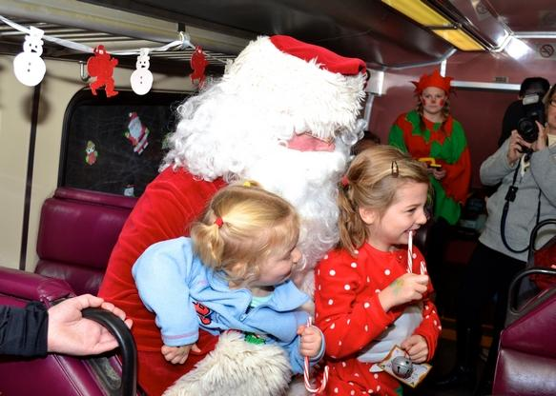

Two children meeting Santa aboard the 7th Annual Scituate North Pole Express on Sunday, Dec. 7, 2014.

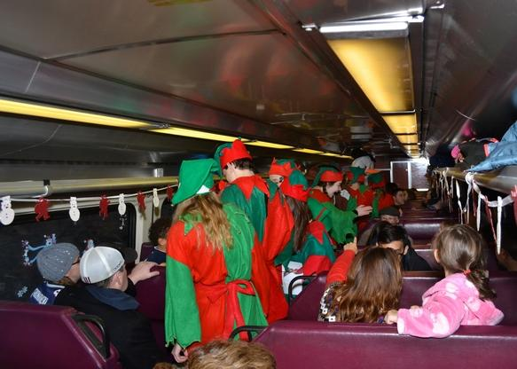

Christmas elves greeting passengers aboard the 7th Annual Scituate North Pole Express on Sunday, Dec. 7, 2014.

