Great skate by the CORSE Foundation
Scituate Mariner Feb 22, 2013 @ 03:15 PM
The CORSE Foundation sponsored an ice skating event at the Pilgrim Skating Arena in February.

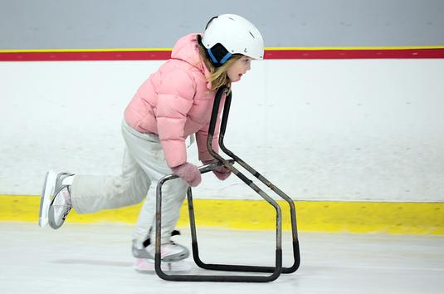
Wicked Local Staff Photos by Robin Chan
Grace Desmet, 8, speeds along the ice with the help of a brace while skating at Pilgrim Arena on Thursday.

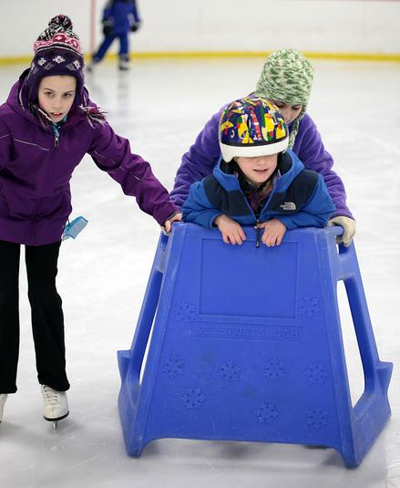
Wicked Local Staff Photos by Robin Chan
Fifth graders Abby Carroll and Maria Collari help CORSE student Drew McClellan, 6, skate around the rink.

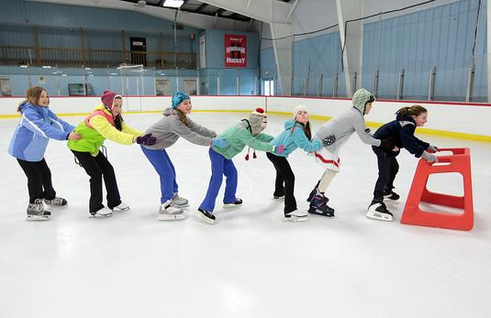
Wicked Local Staff Photos by Robin Chan
Fifth grader Ellen O'Donnell pulls her classmates Cloe Flanagan, Abby Cunie, Katie Granatino, Paige Lydon, Sophie Patterson, and Lauren Brown around the ice rink during the open skate at Pilgrim Arena hosted by the CORSE program on Thursday. Approximately 50-60 students enjoyed the ice before the major storm that hit the region.

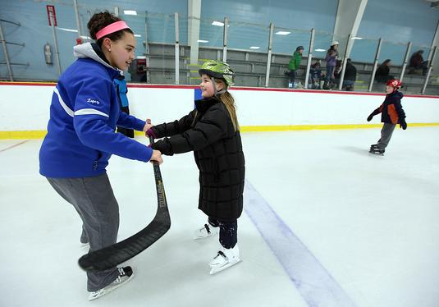
Wicked Local Staff Photos by Robin Chan
Senior Gabby Lopez pulls third grader Rebecca Glowac around the rink with her hockey stick while teaching her how to skate on Thursday.

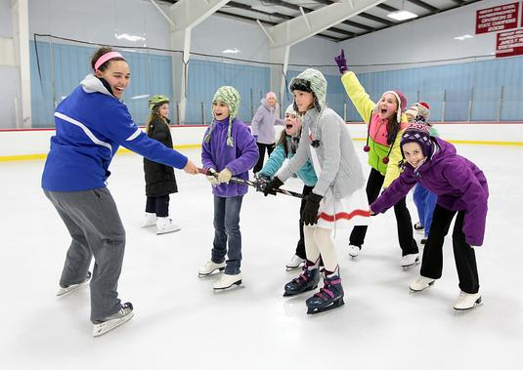
Wicked Local Staff Photos by Robin Chan
Senior Gabby Lopez of the Scituate girls hockey team pulls fifth graders Maria Collari, Abby Cunie, Cloe Flanagan, Sophie Patterson, Katie Granatino (back), and Abby Carroll while enjoying the free skate on Thursday.

Wicked Local Staff Photos by Robin Chan
Second grader Brian Lannon, 8, of the Jenkins School pulls his mother, Sarah, around the rink while enjoying the afternoon at Pilgrim Arena.
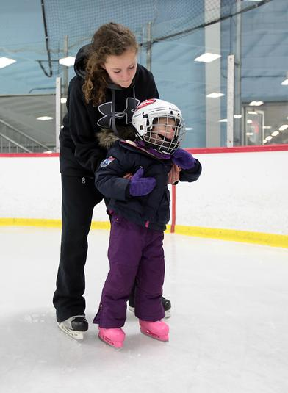
Wicked Local Staff Photos by Robin Chan
Sophomore Oriana McDonough helps Lyla Gates, 3, learn how to skate. Lyla's brother, Zach, is a CORSE student.

Wicked Local Staff Photos by Robin Chan
Fifth grader Emma McClellan carefully skates along the boards while enjoying the afternoon with her friends.

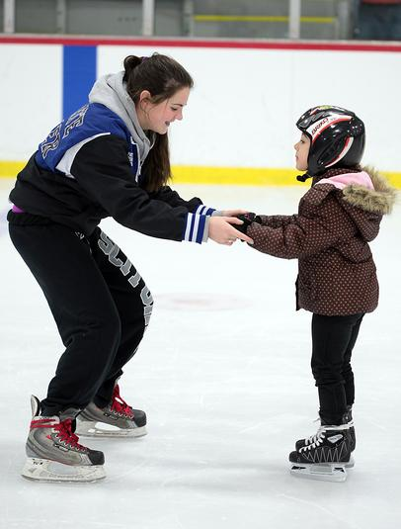
Wicked Local Staff Photos by Robin Chan
Sophomore Corey Murray of the girls hockey team helps Alex Sutton, 6, learn how to skate on Thursday.

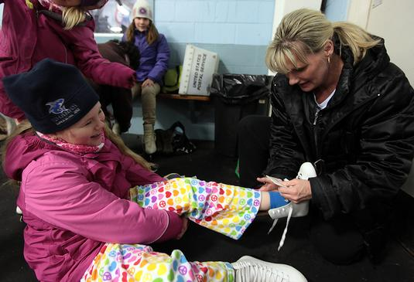
Wicked Local Staff Photos by Robin Chan
Nancy Goyette helps her daughter, third grader Brooke, 9, of the Hatherly School put her skates on before the skate for CORSE at Pilgrim Arena.

Wicked Local Staff Photos by Robin Chan
Nancy Goyette helps her son and CORSE student, Cameron, 6, navigate the ice for the first time in his life.

