All Stars Jiu Jitsu

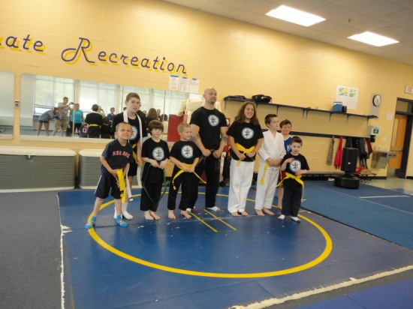
Today I am going to All Stars Jiu Jitsu.

It will be fun to see my friends.

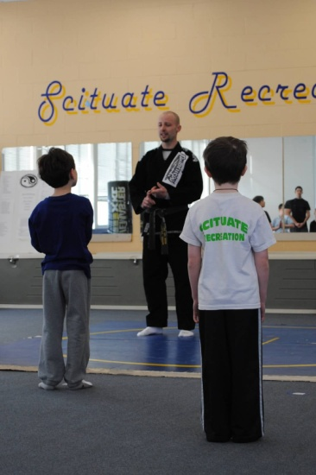
When class starts, Sensei Danny will tell me
to line up. I will find a place on the mat
and stand at attention. It is important to
have a quiet body, looking eyes and
listening ears.

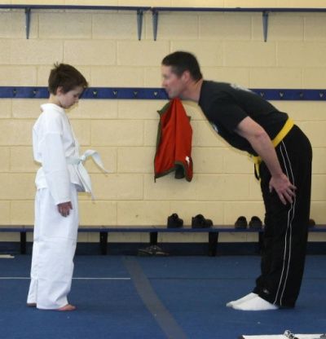

When everyone has found a spot, we will
begin class with a bow to show respect.

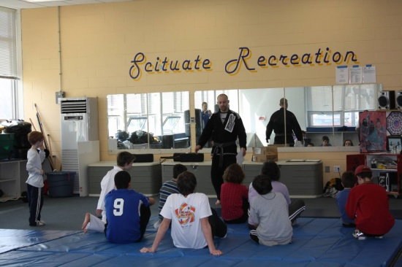
After we bow, the teachers will talk
about the rules of Jiu Jitsu. The three rules
are: self control, respect and patience.
It is important to understand the rules and
what they mean.
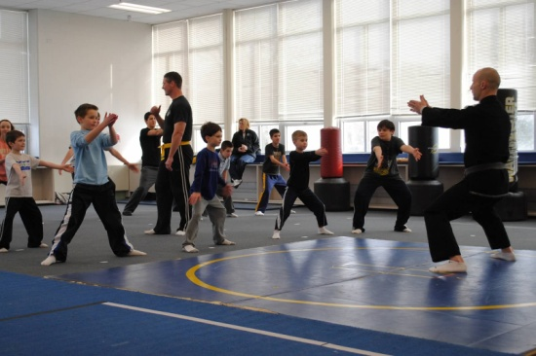

Next we will practice meditation. This is
when we stand tall and focus on taking
slow, deep breathes.

When we are done, we will work on making
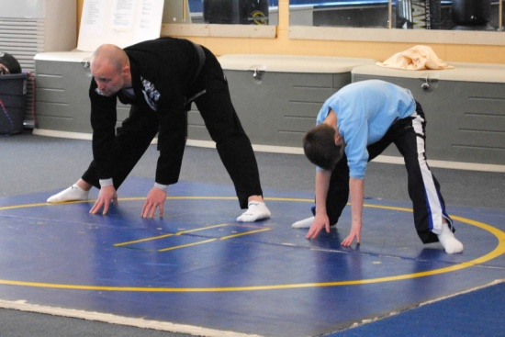
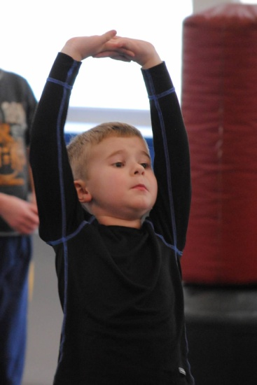
our mind and body strong by doing exercises.
We may do jumping jacks, pushups, kicks,
seal jumps, balancing, floor stretches, blocks
and punches.
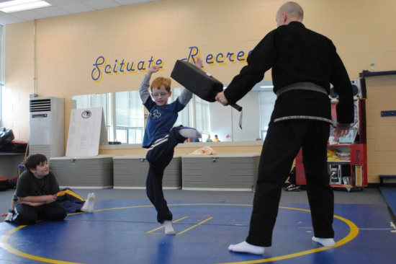
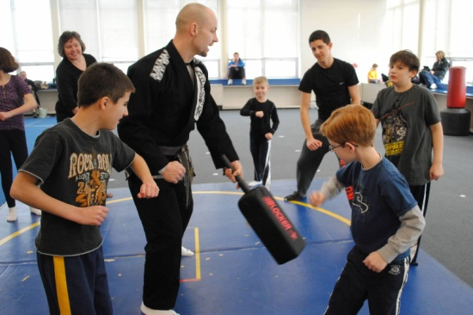

When we are finished, we will practice
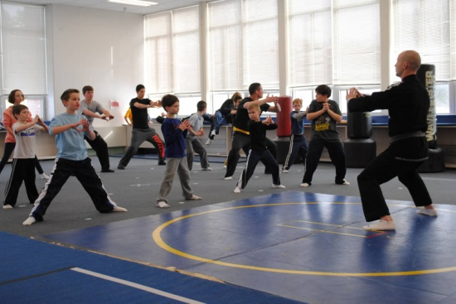
San Chin, this is when we work on focus.
The animal symbol for focus is the snake.
It is important to breathe and make the
hissing sound of the snake. I can do this
by pressing my tongue to the roof of my mouth to hiss and making all my
muscles tight. During San Chin, you must be very serious and keep your
eyes looking straight ahead.

The last thing we will do is play games.
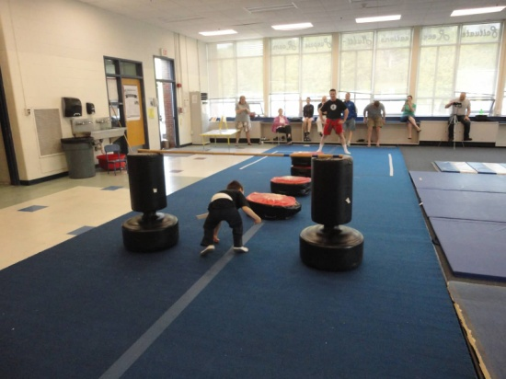
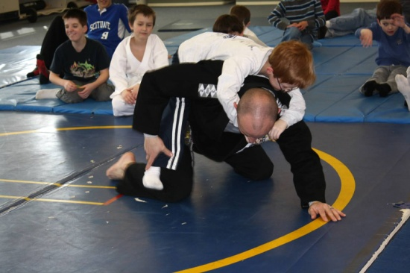
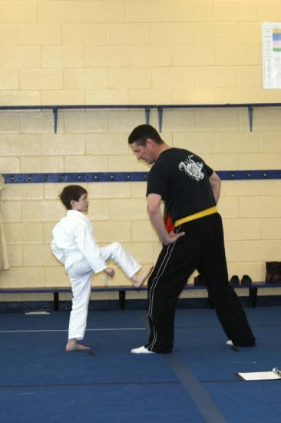

When the game is over, I will come back
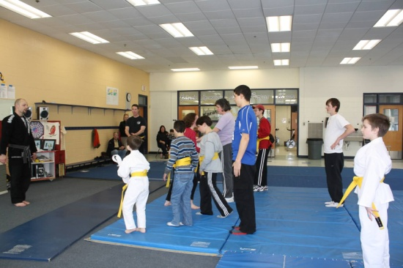
to the mat to finish. I will say thank you
to my teachers.
