CORSE appreciative of continued support from Scituate High basketball

Tuesday
Posted Mar 7, 2017 at 11:41 AM

The following was sent to Scituate High School basketball coach Matt Poirier and Robyn Sullivan of the Scituate High School Basketball Boosters:

Thank you for coordinating our Best Buddies Halftime Court Event at the last home boys' varsity basketball game on Thursday, Feb. 16. To say the students had one of the most exciting and uplifting moments of their lives is an understatement. As they sank the ball into the basket over and over again to the roar of the crowd, they must have felt just as proud as the very talented varsity players we have on the team. It was truly an amazing thing to watch as they surpassed all of our expectations. They already had felt so very special to be invited, and then to perform so wonderfully on the court in front of the crowd was a memory of a lifetime.

We would like to thank you again for continuing to take the time to support the CORSE Foundation and our programs. It is wonderful to be part of a community who support our children with the greatest needs and provides them these inspiring opportunities. On behalf of the CORSE Foundation Board of Directors and community members, we thank you.

- Tracy Johnston, President, Scituate CORSE Foundation

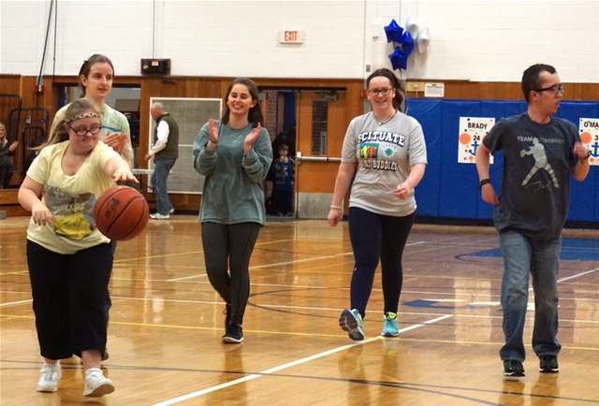
The Best Buddies Halftime Court Event took place during the final boys varsity home game of the season on Thursday, February 16.
