- Riding a bike is possible for disabled teens, children with iCan Bike program
- South Shore YMCA and Scituate CORSE host iCan Bike program, which teaches children and teens with disabilities how to ride bikes independently.

  - 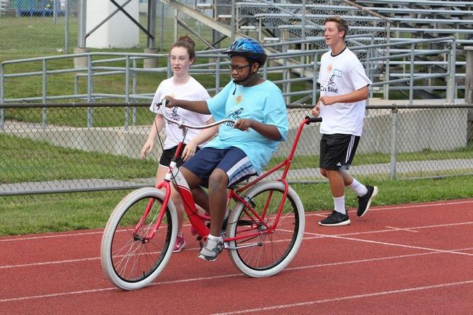

- | Volunteers Kara Murray,15, (left) and jack Fulton, 15, run alongside as Kailen Archibald, 14, of Weymouth, learns to ride a bike on her own during the iCan Bike program, sponsored by Scituate-based CORSE and the South Shore YMCA in Hanover. Wicked Local Staff Photo/Chris Bernstein

- By Kaila Braley kbraley@wickedlocal.com

- Updated Aug 19, 2015 at 1:59 PM

Lucy Falcone rode around the Scituate High School gymnasium on the front of a tandem bicycle, smiling from ear to ear and shouting out to her mom as she passed.

Falcone, 12, of Canton, had never been able to ride a bike before participating in the week-long iCan Bike program, which teaches children and teens with disabilities how to ride bikes independently. Her mom Lauren Falcone said that because Lucy has Down syndrome, she has low muscle tone and it would take a lot of energy to ride a bike on her own. “Even if their child is not riding by the end of the week, [parents] shouldn’t feel discouraged,” Lauren said. “We don’t expect [Lucy] to go dirt biking at the end of the week, but she’s doing very well.”

The iCan Bike program is sponsored by Scituate Community of Resources for Special Education Foundation—known as CORSE—and the South Shore YMCA and ran from Aug. 10 to Aug. 14. Program Floor Supervisor Manda Krimmer said learning to ride a bike is important for those with disabilities. “It helps with self confidence, transportation, exercise, inclusion," she said. "If the family want to go on a bike ride, they can now be included."

Bernie Kilroy, a Norwell resident, said his son hasn’t been able to go on family bike rides before, but after this camp, he might want to come. “It gives him another avenue to enjoy his life and be active,” he said. His son Alex, 14, said his favorite part of the camp was being able to ride on two wheels by himself. “I’ve never done that before,” he said.

To be eligible for the program, participants have to be between the ages of 8 and 22, have a diagnosed disability and be able to walk and wear a helmet. The participants can be from any town on the South Shore. In the third year of the program, there were 30 participants aided by 60 volunteers, and split up into five sessions, which lasted one hour and 15 minutes each day for five days. Volunteers stayed with the same child throughout the week.

For the first few days, the technician at the camp, Kevin Crenshaw, replaced typical bicycle wheels with wide rollers to make the bikes more stable and allow participants to feel secure as they practiced pedaling and keeping their balance. As participants gained confidence and skill, the rollers were changed to be progressively less stable, until riders eventually go outside on the track on two wheels. Two volunteers also spot each participant as they ride, helping to make them feel safe. Some participants can ride on a tandem bicycle along with one of the iCan Bike employees to help get the sense of how to keep their balance.

The technician at the camp also adjusted participants’ bikes based on their skill level so it would be easier to ride at home. Adjustments included installing rollers instead of wheels, or a handle on the back of the bike for a spotter to hold.
“We encourage them to bring their own bikes so we can help transition them to ride at home,” Crenshaw said.

Some children won’t be able to ride on two wheels by the end of the week, but the program is made to match the pace of each child individually, Camp Director in Scituate and CORSE board member Peter Gates said. “There are two type of success—those who learn how to ride on two wheels independently, which is historically about 75 percent of the kids. The other is for kids who are not ready to ride by themselves; they have the opportunity to learn how to ride and be around the other kids,” Gates said.

Gate’s son has participated in the camp in the past, and is the reason Gates joined CORSE. “I initially got involved because I wanted my son to be given the opportunity to meet his full potential,” Gates said.

The volunteers were mostly high school students from Scituate, Gates said. Some of the other volunteers were parents of the children participating--and one volunteer was Gates’ own mother. Gates’ mother, Susan, cheered for 9-year-old Patrick McClelland, of Scituate, who she spotted throughout the week, as he rode along the outdoor track at Scituate High School.

“My favorite part was my relationship with Patrick. He’s so engaging and articulate. He’s an absolute pleasure,” she said.

Volunteer Alece Demetriades, 20, of Scituate, also worked with McClelland. By the end of the week, she said he was able to ride around the track independently on two wheels while she ran around the track behind his bike for entire sessions.

After finishing a lap last Thursday, McClelland got off his bike and ran over to his mom to drink some water and take a break.“I thought that was a whole mile,” he said. His mother and volunteers congratulated him on being able to ride on his own. He was initially scared to try riding a bike, but he said the program has made him feel better about it. “I’m more confident,” he said.

His mom, Angie Annese, thought the program worked really well.
“I didn’t know how to progress him onto two wheels. Then, I saw the bikes and I thought it was a genius idea,” his mother said. “I’m excited and proud.”

This is the third year CORSE has sponsored iCan Bike. During previous years, in 2010 and 2012, the camp was held at the Scituate Middle School, which had a smaller gym that would only host 25 participants.

The program costs $13,000 to bring to Scituate, Gates said, and is funded by camp fees, YMCA grants and fundraising.

The South Shore YMCA was happy to be able to work with CORSE to bring the program to Scituate, Association Director of Inclusion at the South Shore YMCA Lisa Drennan said. “We had the opportunity to bring people who have expertise that we don’t have to the members of our community who would benefit from that,” said Drennan. “We couldn’t do it on our own. They have the equipment and experience.”

Watching the children progress, and how excited the parents are, is one of the most rewarding parts of the program, Gates said. “The look on the faces of parents as their kids learn how to ride bikes—it’s amazing to see,” he said.

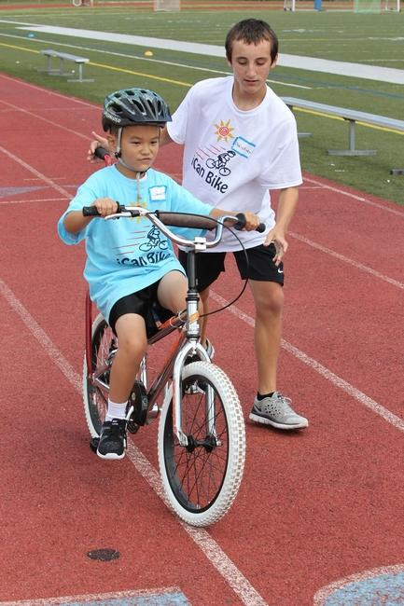
Volunteer Christian Eckelhofer, 15, runs alongside as James Tocchio,8, of Hingham, as he learns to ride on his own during a session of the iCan Bike program at Scituate High School.

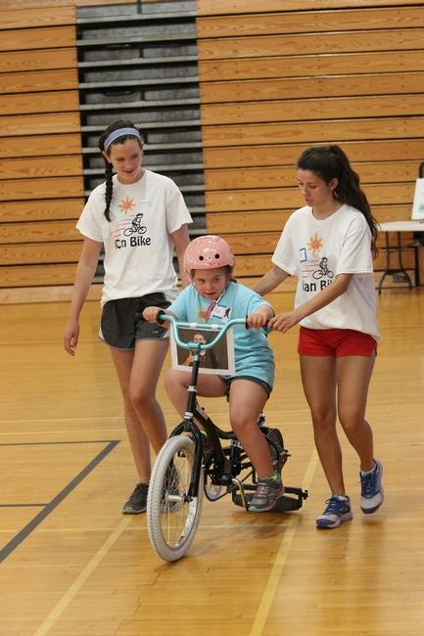

Volunteers Hanna Lydon,15, of Scituate (left) and Sarah O'Donovan, 17 of Newton run alongside as Ava McLaughlin, 9, of Dorchester enjoys independently riding a bike through the iCan Bike program sponsored by CORSE in Scituate and the South Shore YMCA in Hanover.
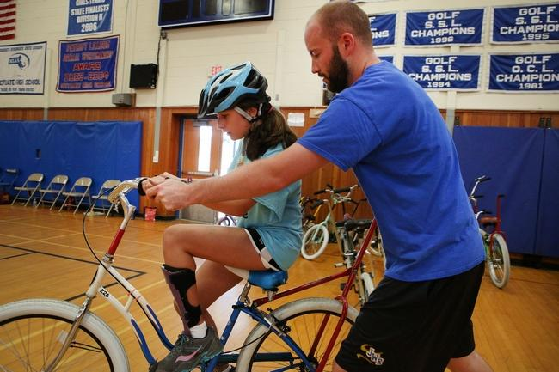
iCan Bike program volunteer Kevin Crenshaw, of Arlington, works one on one with Siobhan Sutherburg, 12, of Canton.

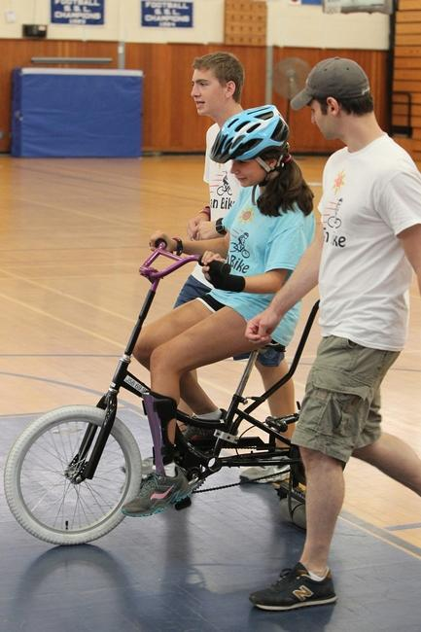
Volunteers Ryan Potts, 17, of Scituate (left) and Jeff Glozzy, 34, of Rolsindale run alongside Siobhan Sutherburg, 12, of Canton, as she enjoys rding a bike idependently with the iCan Bike program. Wicked Local Staff Photo/Chris Bernstein

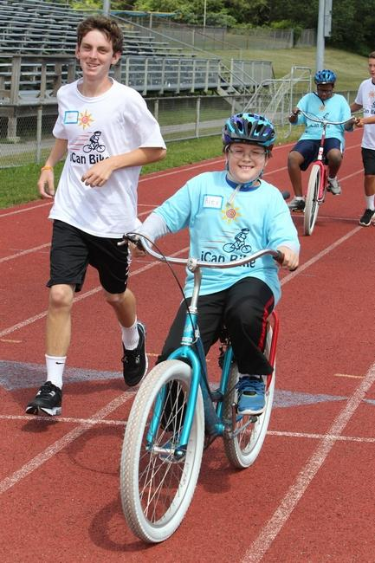
Volunteer Matt DiPesa, 15, runs alongside as Alex Johnson, 10, of Scituate, enjoys riding a bike on his own, thanks to the iCan Bike program hosted by Scituate-based CORSE and the South Shore YMCA.

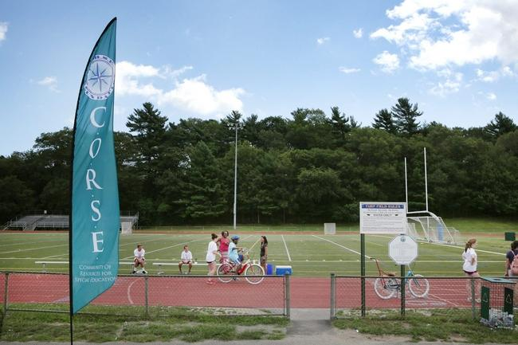

CORSE volunteers assist children with various handicaps ride a bike independently through the iCan Bike program held at Scituate High School last week.

