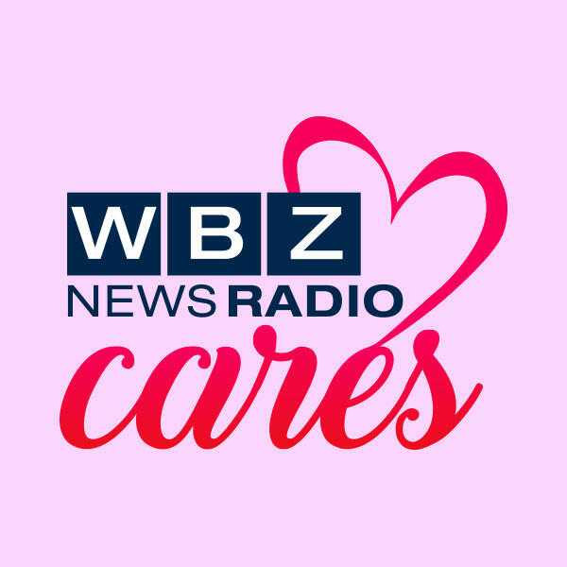

WBZ Cares: CORSE Creators And Mentors
Mar 4, 2020

BOSTON (WBZ-AM) -- Each month, “WBZ Cares” highlights a worthy non-profit organization and tells the story of what that organization does for the community. This month WBZ is profiling The CORSE Foundation (Community of Resources for Special Education) which was established by a group of dedicated parents and educators to raise funds to provide high quality and affordable programming, training, and resources to benefit children with special needs (ages 3-22), their families, and educators throughout South Shore Massachusetts.

WBZ Cares features the CORSE Foundation, providing social, academic, recreational and therapeutic programs for those with special needs throughout the South Shore.

“My son is diagnosed with autism, high-functioning,” said Tracy Johnston, CORSE Foundation President and Co-Founder.

Motivated by her son Billy, Tracy Johnston co-founded the non-profit 14 years ago.

“His first program was Circle of Friends as a preschool social program where he learned those soft social skills that cannot always be taught during the school day. Then he went to the elementary social programs, and then he went to the middle school and the high school social programs. And he also did all of the recreation, sports and camp programs. And you could just see their confidence build, and they made friends outside of school, like they had something to do after school like every other kid,” Johnston stated.

Billy is now 18 and graduating high school. So he grew up in the program.

“The CORSE Foundation was created because of my disability of Autism, so my mom created the CORSE Foundations when I was three, I think,” said Billy Johnston, CORSE Participant and Mentor.

“What have you liked best about it?” asked Shari Small.

“I really liked the CORSE Foundation because it really allows kids who have special, diagnosed with special EDs, special education like me, like autism or down syndrome. And I like that they can do like fun activities and try out new things like karate, basketball, camp, Best Buddies,” outlined Billy Johnston.

He now mentors younger kids through CORSE and holds two jobs.

“I'm a mentor at the Best Buddies Elementary. Today we're going to be seeing the new Sonic the Hedgehog movie, which I'm thinking the kids are going to really like,” commented Billy Johnston.

“Do you like being a mentor?” inquired Shari Small.

“I love being a mentor. It's really good working with the little kids helping them bond with others,” stated Billy Johnston.

CORSE has grown to offer 50 to 60 programs a year and has served nearly 10,000 children and young adults.

WBZ NewsRadio1030's Shari Small Reports

