SCITUATE LETTER/Thanks from Scituate North Pole Express organizers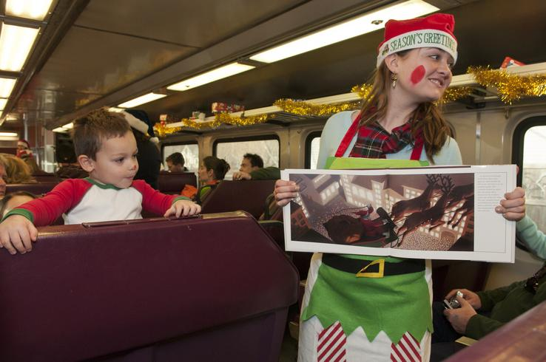
Dylan Barlow, 2, of Abington enjoys the pictures while listening to a reading of the Polar Express.

Scituate —
We would like to express our gratitude and thank everyone who helped make the fourth annual Scituate North Pole Express on Saturday, Dec. 3, a tremendous success. With approximately 2,500 people attending and 90 percent of them visiting from outside of our community they all received a taste of Scituate hospitality at its finest.
Everyone did an amazing job and delighted hundreds of children, due in large part to Scituate High School student volunteers! During the course of the day, about 100 students volunteered as elves, Santa helpers, Frosty, Rudolph, good will ambassadors, both the band and choir entertained as well!
It does take a village to pull together an event of this magnitude and we would like to thank the following individuals and/or groups for making the 2011 Scituate North Pole Express a success. Our thanks to Ken and Val Baker, Jordan Barnes, Alice Beal, Bob Beauregard, Bella Aesthetics, Bergsten Music, Ellen Bernstein, Brooks World Travels Christmas Trees, Mike and Ellen Burke, Megan Coleman, Betty Crowley, Jean DiGiacomondrea, Joann Evans, Field & Sons, Michele Gee, Patty Gilmartin, David Hanrahand, Mike Hayes, Lisa Hebert, Noreen and Richard Hebert, Marynell Henry, HP Hood, Mary Joyce, Frank Judge, Natalie Jurgel, Emma and Kathryn Jurgel, Sue Kamp, Jill and Robin King, Heather Kinney, Anne Lambert, annelambertcreative.com, Joan Lang, Alice LeBlanc, Melanie Legge, Patty Litz, Kathleen Lydon, Marie MacCune, Marianne Martin, Craig Dias and the train crew of the MBTA, Gina McClellan, Jane McGovern, Bob McQuaid, Anne Meyerson, Pat and Paul Murphy, Nancy Murray-Young, Judy Nourse, Jen O’Neill, Kim O’Reilly, Nina Pillsbury, Restaurant Oro, Roche Bros., Tom Rose, Barbara Sabonis, Jay Savage, Scituate High School Students, Band, Choir & Parent Volunteers who were train captains and helped in many other ways, Scituate Town Library, Laurie Taylor, Tingy Sewall, Sue Shillue, Spindrift Quartet from South Shore Men of Harmony, Stop & Shop, Jamie Strobino, Carol Sullivan-Hanley, Susan Tedeschi, Carl Traina, Keaton Trevena, Kendra Vachon, Village Market, George White, Shannon Wilson and Maureen Zucker.
To Peg Patten at the Front Street Book Shop and her tremendous staff who went above and beyond selling tickets, answering phone calls and supporting customers in many ways, thank you! To Elizabeth O’Connell, thank you, you are amazing! We couldn’t have done it without you.
We cannot tell you how many glowing comments we have received from parents, grandparents and the young children themselves who attended, both verbally and in writing.
Merry Christmas and thank you all for your generosity of time and talent.
Lorraine Devin, Event Chair, Co-Vice President, Scituate CORSE Foundation
Tracy Johnston, President, Scituate CORSE Foundation
Jim Trevena, President, SHORE

