Scituate CORSE Foundation continues fundraising campaign

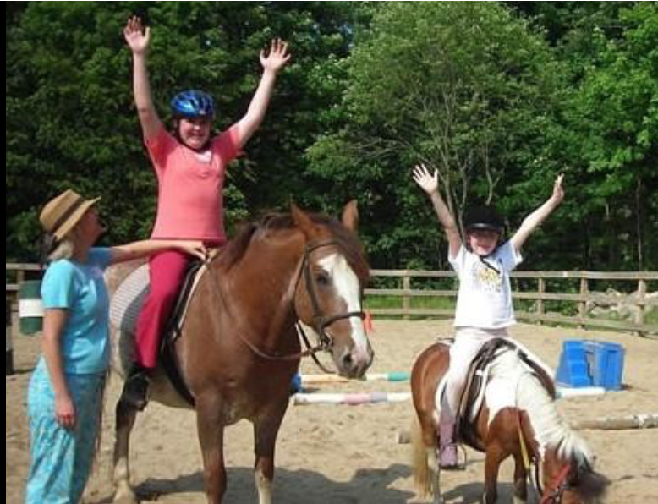

Scituate CORSE Foundation celebrated 10 years in 2016 and has launched a campaign to help support the organization.

By Ruth Thompson
rthompson@wickedlocal.com
Posted Dec 24, 2016 at 8:00 AM

Join the Scituate Community of Resources for Special Education - CORSE - Foundation in celebrating its 10th anniversary by taking part in the Circle of Giving 10 Years Campaign.

Give $10 for 10 years, up to $5,000 as a Special Anniversary Sponsor. Any level of donation is appreciated.

CORSE, which celebrated its 10th anniversary on Feb. 14, 2016, has designed an innovative model within a blended framework of integrated and specialized social, educational and recreational programs so children with special needs can reach their full potential. The variety of programs are staffed appropriately through customized staffing ratios and special education expertise so all children, those with and without special needs, can successfully participate together within their community.

Help CORSE honor this milestone year.

For sponsorships of $1,000 or more, they are glad to work with you to be the "official sponsor" of a program you would like these funds dedicated to (i.e. Maritime Adventures, Best Buddies, iCan Bike).

$500 Sponsor will provide for recreation equipment, one month of swim program, SHS scholarship for a graduating student receiving special education services, and parent and staff training program.

$250 Sponsor will provide for Best Buddies field trip activity, financial assistance for a child to attend a Maritime, iCan Bike or summer camp, personal aide for a child needing assistance in a recreational program, sports programs' counselor salaries.

$100 Sponsor will provide for a bus for a Best Buddies program, financial assistance for a child to attend a social, academic or sports program, Angel tickets on the North Pole Express for a family of four.

$50 Sponsor will provide for books or supplies for a social, academic or Best Buddies program, one session of music therapy or yoga, financial assistance for a child to attend a summer, social or academic program.

$25 Sponsor will provide for snacks for a social, academic or Best Buddies program, peer mentor Thank You gift, Angel ticket for a child to ride the North Pole Express.

Multiple $10 donations add up quickly.

All donations are tax-deductible with receipts provided.

Employer matching donations increase the impact of your contribution.

CORSE has run 453 programs with 5,907 registrations and 949 volunteer mentors investing more than $835,000 back into our community through programming and resources.

Help keep CORSE going strong for another 10 years.

For more information visit www.corsefoundation.org

