All Stars Karate

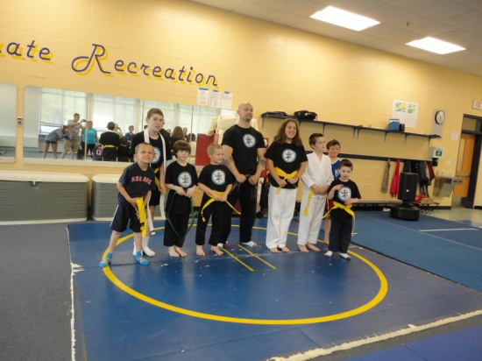
Today I am going to All Stars Karate.

It will be fun to see my friends.

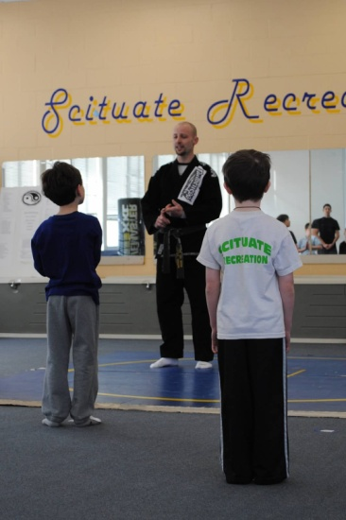
When class starts, Sensei Danny will tell me
to line up. I will find a place on the mat
and stand at attention. It is important to
have a quiet body, looking eyes and
listening ears.

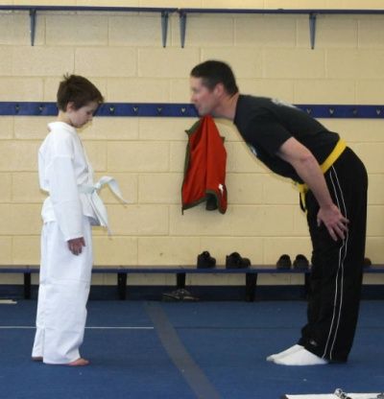

When everyone has found a spot, we will
begin class with a bow to show respect.

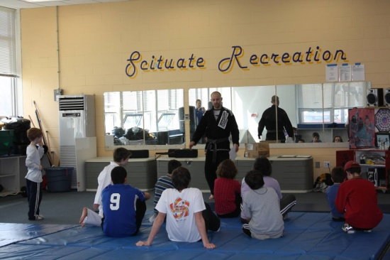
After we bow, the teachers will talk
about the rules of Karate. The three rules
are: self control, respect and patience.
It is important to understand the rules and
what they mean.
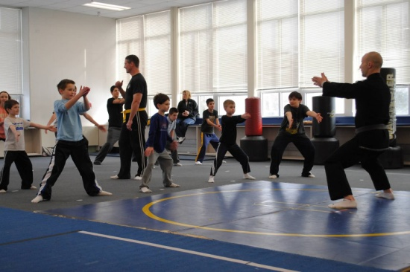

Next we will practice meditation. This is
when we stand tall and focus on taking
slow, deep breathes.

When we are done, we will work on making
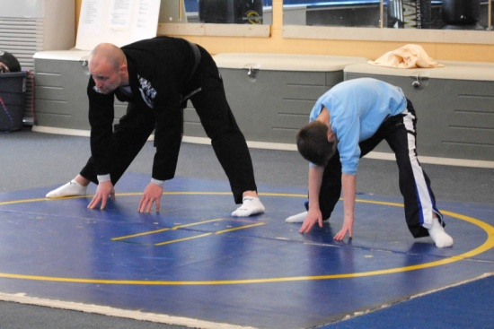
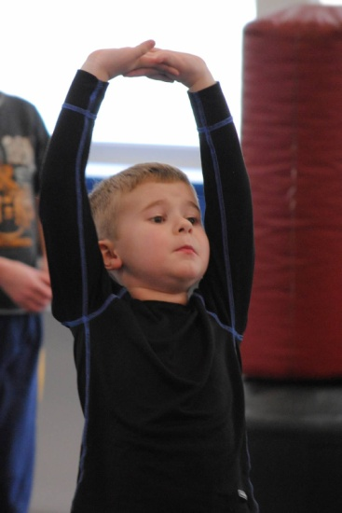
our mind and body strong by doing exercises.
We may do jumping jacks, pushups, kicks,
seal jumps, balancing, floor stretches, blocks
and punches.
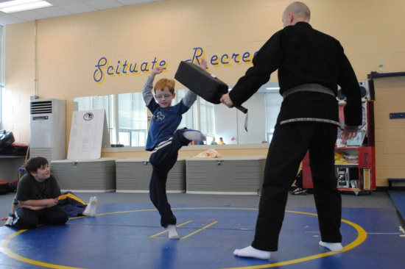
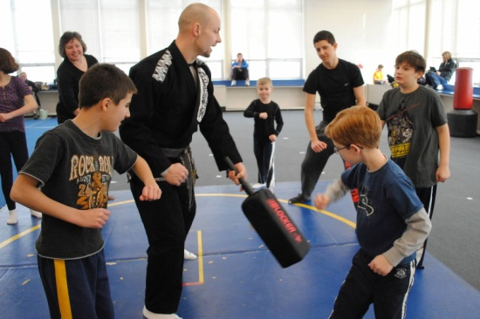

The last thing we will do is play games.
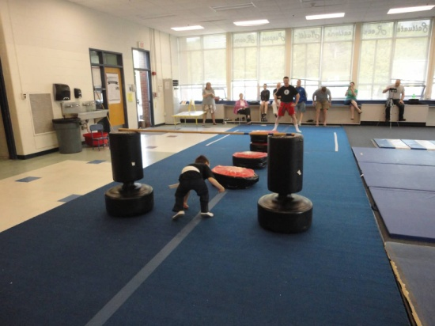
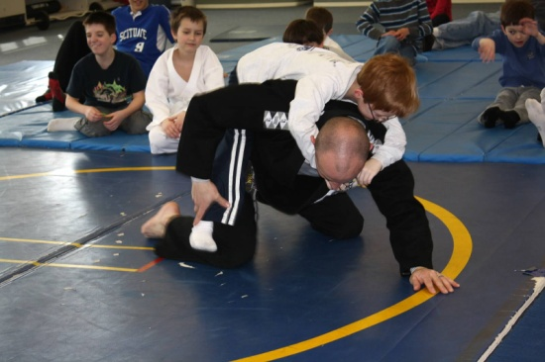
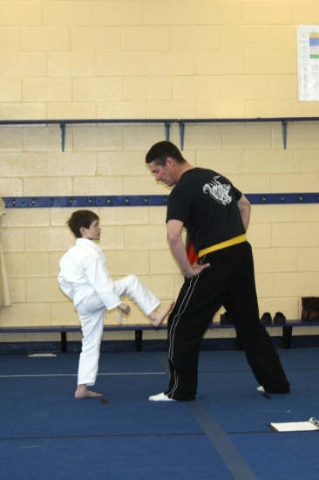

When the games are over, I will come back to the mat to finish. I will say thank you to my teachers.
