**All Stars Tennis**

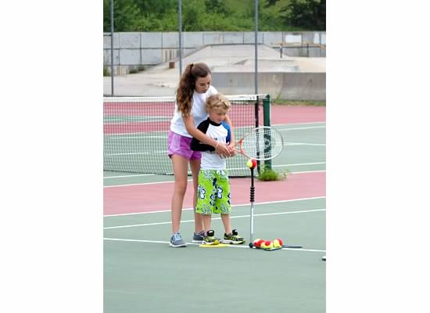

Today I am going to Tennis.

I need to wear my sneakers and

bring plenty of water.

It will be fun to see old friends and

make some new friends, too.

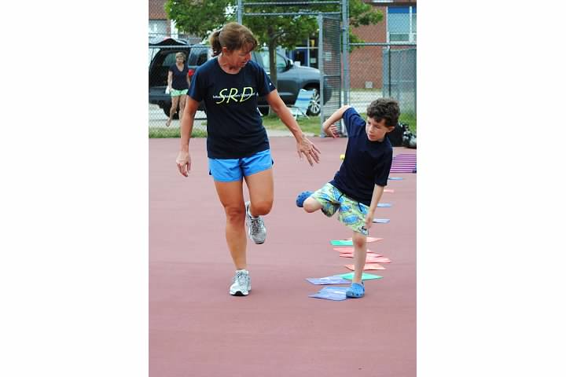

The coaches will start us off with

a warm-up lap around the court.

When we are finished, we will start

our group stretch, we always count together.

We will do things like touching our toes,

jumping jacks, sit ups and pushups.

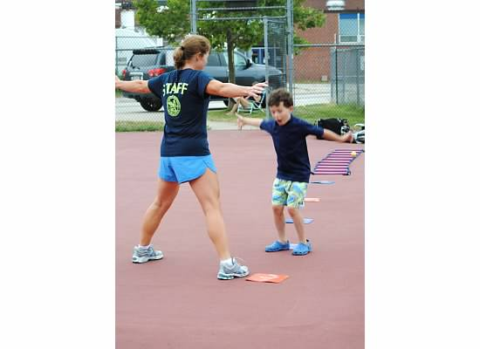

It is important to follow the rules and

hug my racquet while I am waiting for my turn.

Next, we will practice some drills to

help us hit the ball. It is important to

listen to the coaches so we know

what to do. The coaches will help me

learn to hit the ball. The most

important thing to do is to try.

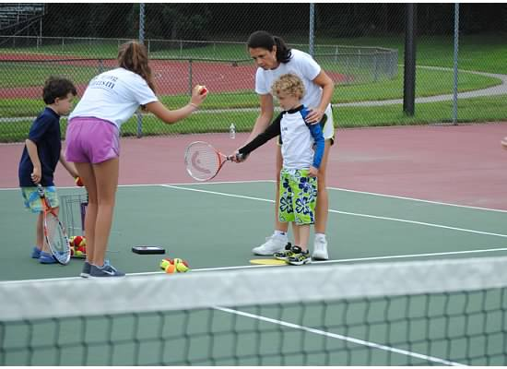

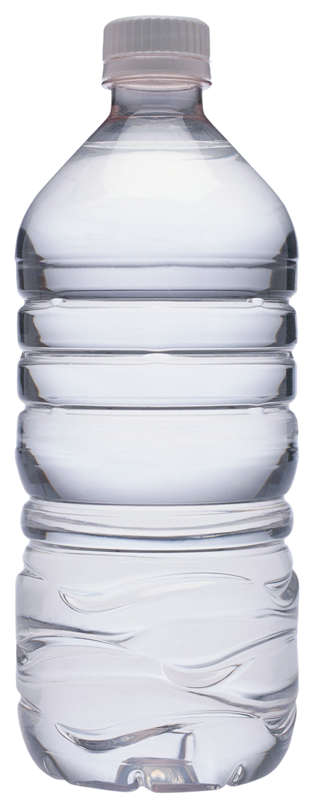

When it is time for a water break, everyone

will stop and have something to drink.

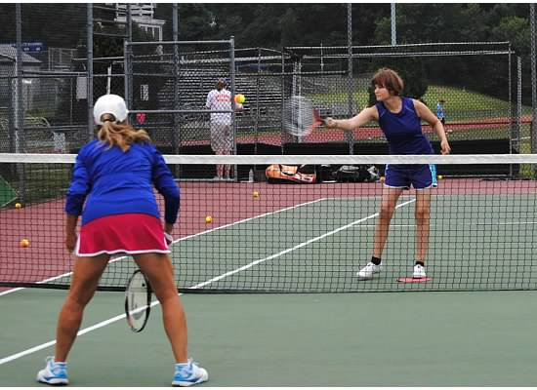

Then, we will come back to the

group and play games.

Next, it’s time for games like Red Light, Green Light.

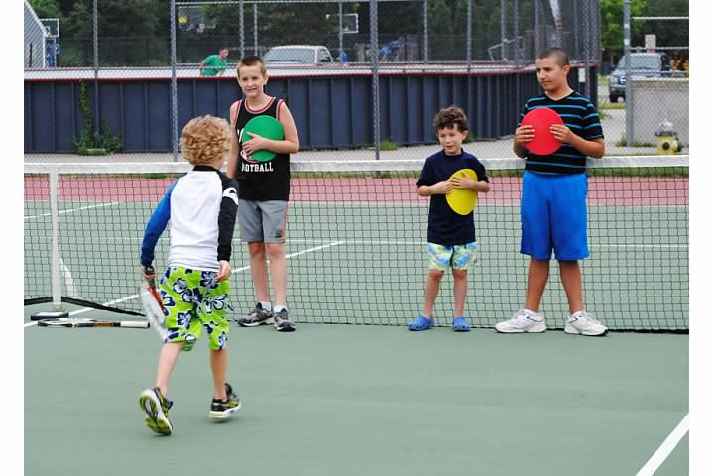

This is a great chance to learn a new game and get to know my friends.

The last thing we do is the group cheer.

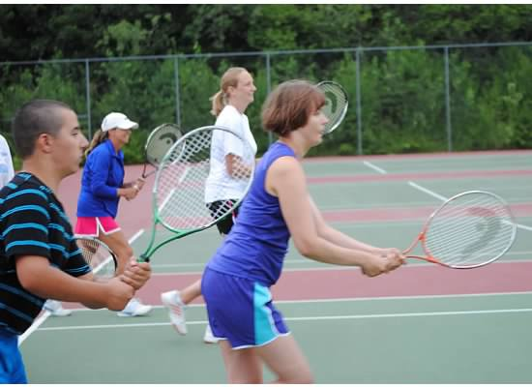

**Playing tennis is fun with friends!**